**Media Type-Based Billing**

**1. Introduction**

This document outlines the system design for implementing media type-based billing and GL account handling within media plans in the Nexelus application. These enhancements will allow users to generate separate billing schedules and assign different GL accounts based on media types, addressing the needs of clients who require more granular billing and financial control.  
 **2. Problem Statement**

Digital agencies frequently bill by media type for the same campaign, allowing for precise and transparent cost allocation across various advertising platforms like display, social media, search, and video. For example, a campaign may involve running banner ads on display networks, sponsored posts on Instagram, Google search ads, and YouTube video ads. Each of these media types typically has different rates, ad formats, targeting methods, and performance metrics, which affect overall costs.

This method of billing provides clients with detailed visibility into how their budget is distributed across channels. For instance, a client may see that 40% of their budget went to search ads, 30% to social media, and 30% to video, helping them evaluate the performance of each medium individually.

However, it's important to note that not all clients bill this way. Some clients prefer a more consolidated billing structure, where campaign costs are grouped together under one GL (General Ledger) account for simplicity, without breaking it down by media type. This approach might be more common among clients with simpler financial reporting needs or smaller campaigns. For clients who do use separate GL accounts for each media type, it facilitates more detailed financial reporting, allowing for better budget tracking and performance evaluation across channels.

**Current System Limitation**:  
  
In the current system, users cannot generate separate billing schedules for different media types within the same media plan. All media types within a media plan are tied to a single set of GL accounts based on service type / trx Type, which limits financial flexibility. If users want to bill separately by media type, they are required to create multiple media plans / service types—one for each media type. This adds complexity to campaign management, reduces efficiency, and limits the ability to provide detailed financial tracking and reporting by media type.

**3. Current Process**

In the current system, users manage media plans through two sections: **Vendor Placements** and **Client Billing**. After entering details about media purchases with vendors in the Vendor Placements section, users move to the Client Billing section to generate the billing schedule. The Vendor Placements and Client Billing sections are housed in separate tabs within the media plan, and the billing schedule is only generated once all vendor placement details are finalized.

At present, the system generates a **single monthly billing schedule** that consolidates all media types within a media plan. Users enter the spend the Vendor Placements section, and the system generates a unified billing schedule that covers all media types (e.g., digital, print, and TV) without distinction. To generate this schedule, users go to the Client Billing tab and press the **"Generate Client Schedule"** button, which triggers the system to review the spent data and create the relevant billing lines for the entire media plan.

The **GL account handling** in the current system is tied to **service type** and **transaction type**. Each media plan is associated with a single service type, and the GL account tied to that service type applies to the entire media plan. While different fields within a single client billing line may use distinct GL accounts depending on the transaction type, there is no way to differentiate GL accounts by media type. This results in all media types within a media plan being tied to the same set of GL accounts. We can possibly use this allow users to have different GL account for different media type within one service type.

**Limitations of the Current Process**

The current system has two main limitations:

1. **Single Billing Schedule**: Users cannot generate separate billing schedules for different media types within the same media plan. If separate billing is required by media type, users must create multiple media plans, each representing a different media type, which adds unnecessary complexity.
2. **GL Account Restriction**: Since all media types within a media plan share the same GL account(s), there is no flexibility to track costs and manage financials by media type. This can limit financial reporting capabilities, particularly for clients running multi-channel campaigns.

**3. New Implementation**

### **3.1. Dedicated Media Type Field**

To implement media type-based billing, a **dedicated field** for **Media Type** will be added at the placement level.

* **Media Type Field**: A dedicated field will be created for **Media Type** at both the **vendor placement** and **client billing** levels. Please note that “Media Type” will be a **variable name**.
* **Backend Management**: Initially, media types will be handled directly in the database without a user interface (UI). The values for this field will be predefined and added to the database.
* **Future UI for Media Type**: In future releases, a UI will be introduced to manage the **Media Type** field, allowing users to add, modify, and delete media types.

**UI and Excel Access**: The new filed “Media Type” will be available through both the **UI** and the **Excel import/export template**, allowing users to specify media types during placement creation or via import/export processes.

**3.2 Segregated Billing Schedule by Media Type**

* The system will allow **separate billing schedules** for each media type under a single media plan.
  + After entering vendor placements, users will continue to generate billing schedules by pressing the **"Generate Client Schedule"** button in the client billing section.
  + However, the billing schedule routine will now segregate billing by media type, producing separate billing lines for each type.
  + For instance, if a media plan includes digital, print, and TV placements, the system will generate a separate billing schedule for each media type.

**3.3 Client-Level Billing Settings**

* A new client-level option will be added, allowing users to specify whether billing schedules should be generated separately by media type.  
    
  **During this phase, the values will be managed directly in the database. A dedicated UI for handling these values will be introduced in future releases**

**3.4 Level 3 Override**

* The media-type billing setting at the **client level** will default to the **Level 3 / media plan level** for all media plans under that client.
  + Users will have the flexibility to override this setting at the media plan level, allowing some media plans to generate billing by media type while others do not.

**During this phase, the values will be managed directly in the database. A dedicated UI for handling these values will be introduced in future releases**

**3.5 Group Rule Management**

* **Group rules** will control who can manage media type billing settings at both the client and media plan levels.
* The system will use the existing **Group Rules UI** to manage permissions, ensuring that only authorized users can update billing configurations.

**We will add this rule when we add fields n UI.**

**3.6 GL Account Assignment by Media Type**

* The system will now assign **different GL accounts** based on the selected media type for each placement.
  + The "Media Type" field will determine which GL account is used for each placement, allowing for more detailed financial tracking and reporting.
  + This eliminates the current limitation, where all media types within a media plan are tied to the same GL account(s), providing enhanced financial control.

**It is not part of this Phase. We will consider it for future phases if needed. For now, we will focus only on generating billing schedule.**

**4. UI Changes**

The following changes will be made to the user interface to support the new media type functionality:

**4.1 Client Profile**

**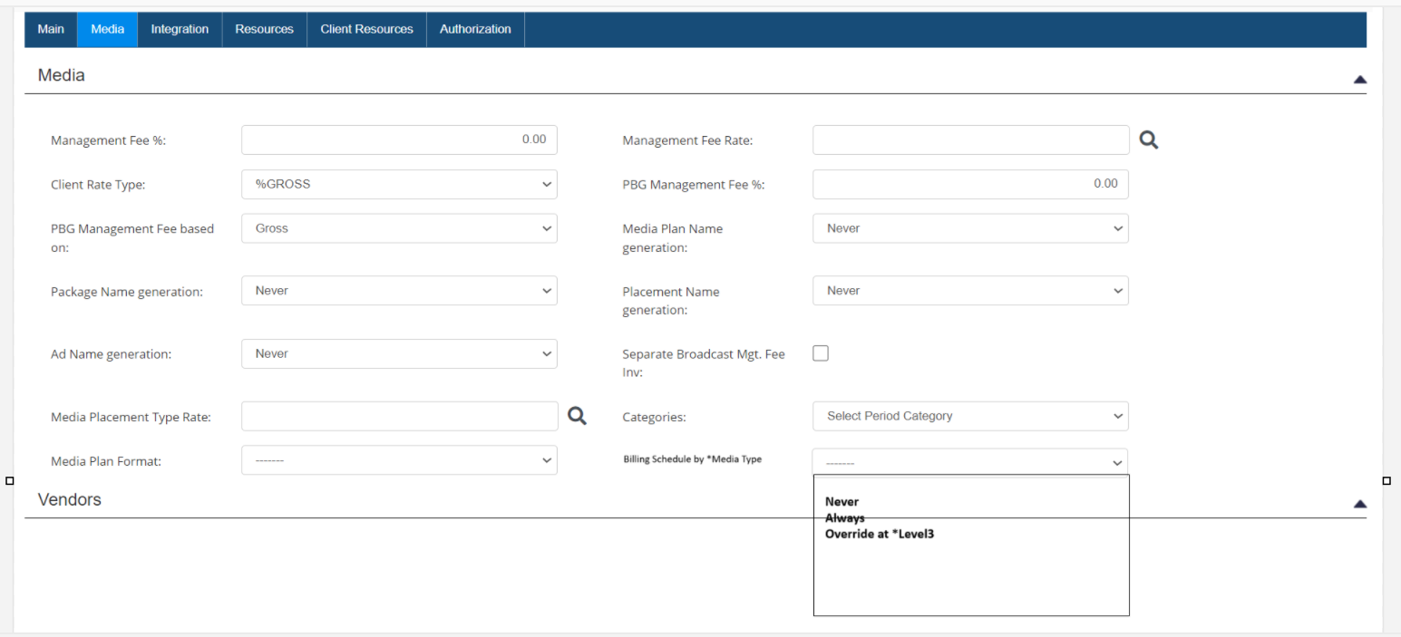  
  
It is not part of this phase. Will be implemented in future releases. For this Phase, we will manage these settings from backend manually.**

**4.2 level3 on Media Plan**

**It is not part of this phase. Will be implemented in future releases. For now, we will manage this setting from backend.**

**4.3 Media Type Field in Vendor Placements UI**

**New Placement UI**

* A new **"Media Type"** dropdown field will be added to the **Vendor Placements** section of the media plan.
  + This dropdown will allow users to select the media type for each placement from a predefined list.
  + The field will be located near the other placement details (e.g., amount, vendor, dates) to ensure easy access when entering or modifying placements.
  + This field will become mandatory (**Red Color**) based on “Billing Schedule by Media Type” setting at the media plan / Activity level. This filed will be mandatory if “Billig Schedule By media Type” is checked at the Level3 / media Plan level which will indicate that billing schedule should be generated by media type. If this setting at media plan / level3 is unchecked. System will not make this field mandatory.
  + Default value will be “Select Media Type” for this field.

**4.4 Excel Import/Export Template Update**

* The **Excel import/export template** for placements will be updated to include the "Media Type" field.
  + This will allow users to specify the media type directly when importing placements into the system.
  + Validation will ensure that only valid media types from the dropdown list are accepted during the import process.
  + We will add this filed after the “Placement Name”. Please reconfirm the index where we will be adding this filed before starting implementation.
  + This field will be mandatory based on setting at media plan / Level3 as described above in 4.3 section.

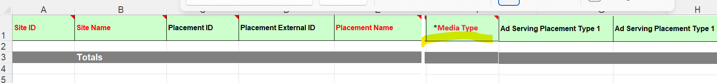

**4.6 – Client Schedule Changes**

The following changes will be implemented to the Client Schedule UI if the following 2 conditions meets.

**Pre-Conditions:**

1 - The Biling Schedule by Media Type on Level3 is marked as Yes.

If above condition is not satisfied, the system will maintain the existing billing process without applying segregation

System will work as following if Billing Schedule by Media Type is checked at media Plan level and user presses the “generate Schedule Button”

**1 – Validation**

The System must ensure that a media type is selected for all vendor placements. If any placements are missing a specified media type, the system will display an error message: “Media Type is not defined for some Vendor Placements. Please specify a Media Type for all placements before proceeding with the current process.”

**2 - Totals by Media Type.**

The system will display media spend by media type under media spend Field. The system will calculate these values based on media type defined at the placement / package level. Consider the example below.

**Vendor Placement**

**Vendor / Site Dates Placement Ext. Cost Media Type**

Google 01/01-2025 – 12/31/2025 Placement 1 12000.00 Digital

Google 06/01-2025 – 6/31/2025 Placement 2 1000.00 Search

YouTube 01/01-2025 – 06/30/2025 Placement A 1000.00 Digital

Facebook 01/01/2025 – 03/31/2025 Placement 1 3000.00 Social

Instagram 01/01/2025 – 06/30/2025 Placement A 6000.00 Social

System will Display following totals on Client billing under Media Spend field.

Digital 13000.00

Search 1000.00

Social 9000.00

**2 – Generate Schedule for each Media Type Separately.**

Once user clicks the “Save” button on generate schedule UI, system will generate separate billing schedule for each media type.

**Current Process:** Currently the system generates 1 client billing line for each month based on vendor placement start and end date. For example, based on Vendor Placement Example below

**Vendor / Site Dates Placement Ext. Cost Media Type**

Google 01/01-2025 – 12/31/2025 Placement 1 12000.00 Digital

Google 06/01-2025 – 6/31/2025 Placement 2 1000.00 Search

YouTube 01/01-2025 – 06/30/2025 Placement A 1000.00 Digital

Facebook 01/01/2025 – 03/31/2025 Placement 1 3000.00 Social

Instagram 01/01/2025 – 06/30/2025 Placement A 6000.00 Social

With vendor lines spanning from 01/01/2025 to 12/31/2025, the system will generate 12 client billing lines, one for each month as below.

**Dates Media Spend**

01/01/2025 – 01/31/2025 4,000.00

02/01/2025 – 02/28/2025 4,000.00

03/01/2025 – 03/31/2025 4,000.00

01/04/2025 – 04/30/2025 3,000.00

05/01/2025 – 05/30/2025 3,000.00

06/01/2025 – 06/30/2025 4,000.00

07/01/2025 – 07/30/2025 1,000.00

08/01/2025 – 08/30/2025 1,000.00

09/01/2025 – 09/30/2025 1,000.00

……..

For more details on client schedule, please go through User Manual and previous documentation on client billing schedule.

**New Implementation:** with new implementation system will generate billing schedule separately for each media type.

**Vendor Data**

**Vendor / Site Dates Placement Ext. Cost Media Type**

Google 01/01-2025 – 12/31/2025 Placement 1 12000.00 Digital

Google 06/01-2025 – 6/31/2025 Placement 2 1000.00 Search

YouTube 01/01-2025 – 01/30/2025 Placement A 1000.00 Digital

Facebook 01/01/2025 – 03/31/2025 Placement 1 3000.00 Social

Instagram 01/01/2025 – 06/30/2025 Placement A 6000.00 Social

Considering the same vendor data. System will generate billing schedule separately as below

a - Digital has t0tal media spend of **13000.00** and Dates Span for schedule will be 01/01/2025 to 12/31/2025 as Placement under digital media types are within this range that’s system will generate 12 lines for Digital , one for each month and will allocate spend based on current logic for each month.

b - **Social** has **1000.00** and spans only for June, that’s why system will generate only 1 line for Social for month of June with 1000.00 spend

c - **Social** has **9000.00** spend across 6 months (Jan – June) that’s why system will generate 6 lines ( 1 for each month) for social and will allocate spend based using only social lines.

Following will be the schedule in case if user generates the schedule based on above data.

**Media Type Dates Spend**

**Digital** 01/01/2025 – 01/31/2025 1000.00

**Digital** 02/01/2025 – 02/28/2025 1000.00

**Digital** 03/01/2025 – 03/30/2025 1000.00

**Digital** 04/01/2025 – 04/30/2025 1000.00

**Digital** 05/01/2025 – 05/30/2025 1000.00

**Digital** 06/01/2025 – 06/30/2025 2000.00

**Digital** 07/01/2025 – 07/30/2025 1000.00

…….

**Social**  06/01/ - 06/30 1000.00

**Search** 01/01/2025 – 01/31/2025 2000.00

**Search** 02/01/2025 – 02/28/2025 2000.00

**Search** 03/01/2025 – 03/30/2025 2000.00

**Search** 04/01/2025 – 04/30/2025 1000.00

**Search** 05/01/2025 – 05/30/2025 1000.00

**Search** 06/01/2025 – 06/30/2025 2000.00

**4.7 – New Client Line**

* A new **"Media Type"** dropdown field will be added to the **Client Line** section of the media plan as well
  + This dropdown will allow users to select the media type for each client line when entering adding / updating line manually.
  + This field will become mandatory (**Red Color**) based on “Billing Schedule by Media Type” setting at the media plan / Activity level. This filed will be mandatory if “Billig Schedule By media Type” is checked at the Level3 / media Plan level which will indicate that billing schedule should be generated by media type. If this setting at media plan / level3 is unchecked. System will not make this field mandatory.
  + Default value will be “Select Media Type” for this field.

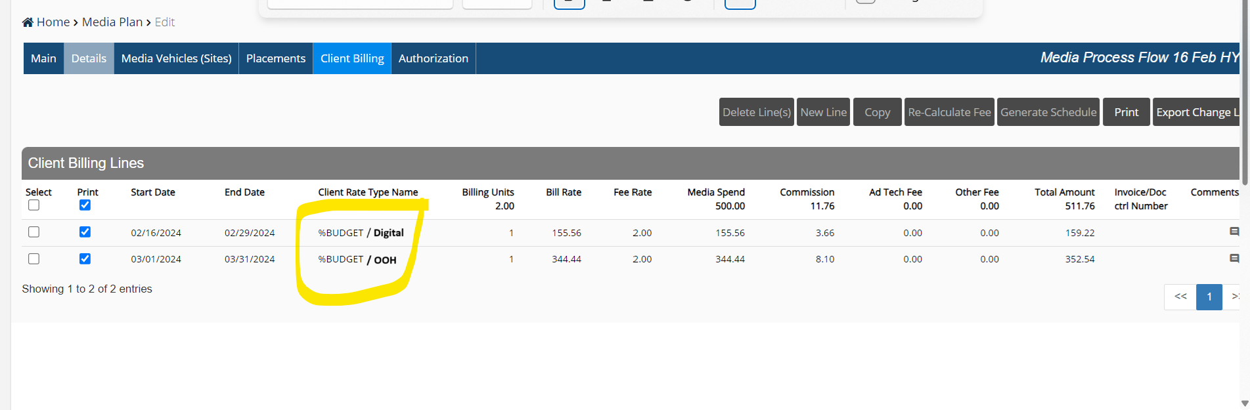

* + We need to display Media type associated with Client billing line in the Client line Grid as well. Because of space issue, we can display Media type with client rate type name as shown above. Please note that Media type in grid will be displayed only if “Billing Schedule By Media Type” setting at the media plan / level3 level is checled.

**4.8 – Billing Setup Changes**

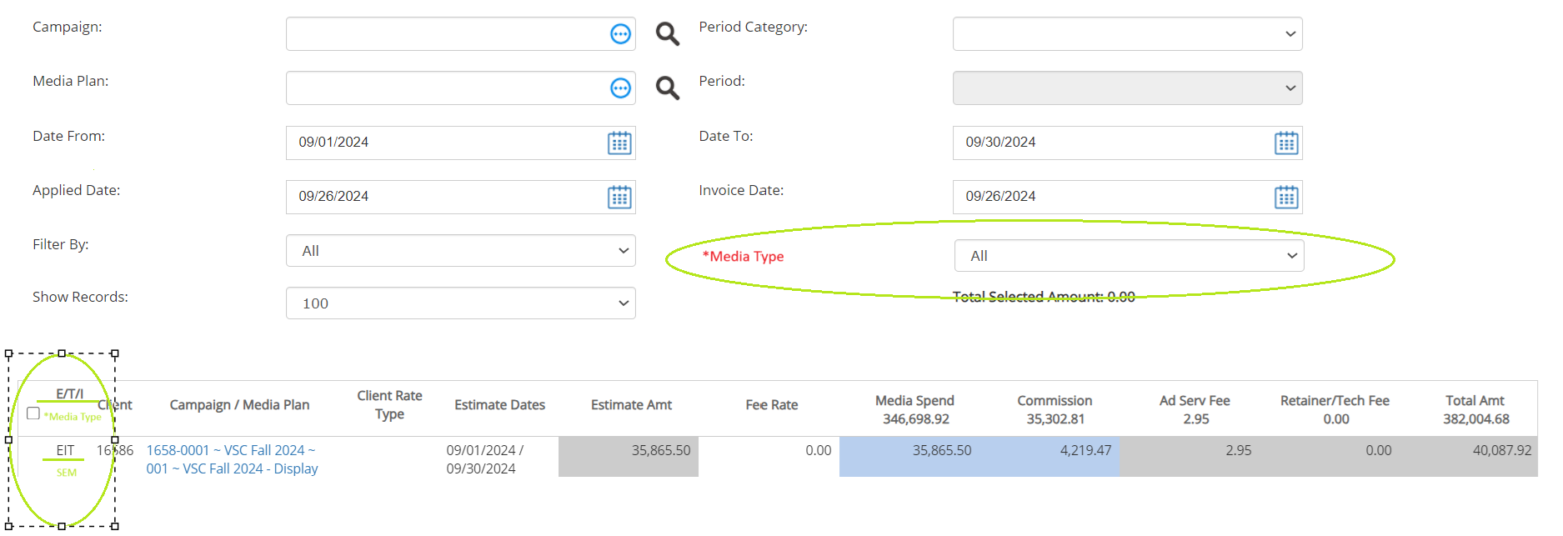

* A new search filter **"Media Type"** dropdown field will be added to the **billing setup** section of the media plan as well
  + This dropdown will allow users to search data by media type.
  + If any media type is selected in this field. The system will return only records for selected media type.
  + Default value will be “Select Media Type” for this field.
  + Furthermore, the system will display media type in status column line(s) grid as shown in image above. This value will be shown only if there is a media type defined at the client line level. For example, if there is no media type stamped on client line, system should only Display “EIT” not .

**4.9 Reconciliation Changes**

Note needed in this phase. Will discuss later

**5. System Behavior**

**5.1 Historical Data Handling**

* The new **"Media Type"** field and associated changes will apply only to new placements and media plans going forward.
  + Historical data and existing media plans will remain unchanged.

**5.2 Error Handling and Validation**

* For **Excel import**, the system will validate that the "Media Type" field is populated correctly when the client requires media-type-based billing.
  + If a media type is missing or invalid, the system will flag the error and prompt users to correct the issue before successfully importing placements.

**5.3 Notifications and Logging**

* The system will not generate notifications or alerts when a user overrides the client-level media-type billing setting at the media plan level.
  + The system will automatically handle these overrides without requiring manual logging or notifications.

**6. Future Enhancements**

* **Media Type Management via UI**: In future phases, a UI will be introduced to allow administrators to manage media type values directly.
* **Advanced Permissions for Media Type Management**: Granular permissions will be introduced, controlling which users can add, modify, or delete media types.
* **Enhanced Reporting**: Future reporting enhancements may include media-type-specific reports to provide clients with more detailed insights into their spend across various media types.

**7. Conclusion**

This system design introduces the ability to generate media-type-based billing schedules and assign different GL accounts based on media types, providing more flexibility and control over financial reporting. By allowing users to manage multiple media types within a single media plan and automatically generate separate billing schedules, this enhancement meets the needs of clients requiring more granular financial tracking.

**Project Name: Historical Mapping Table for Client-Vendor Linkage**

**Date: October 10, 2024**

**Prepared by: Asim Jamil**

**1. Introduction**

**1.1 Problem Statement**

In the current system, **client lines are generated based on vendor lines**, but vendor information is not stored directly on the client lines. This creates a challenge when clients request visibility into which vendors contributed to their billing lines. Since multiple vendor lines may contribute to a single client line, and the vendor information is not linked to the client line, dynamically retrieving this data at runtime becomes complex and inefficient.

**1.2 Purpose**

The purpose of this project is to implement a historical mapping table that captures the relationship between client lines and vendor lines at the time of client line generation. This mapping will allow easy retrieval of vendor details linked with client lines for reporting and querying purposes, addressing the visibility issue when clients require vendor-related billing information.

**1.3 Background**

Clients bill based on client lines, but in some cases, they require visibility into the vendors associated with their billing lines. Although client lines are generated based on vendor lines, the system does not store vendor information directly on the client lines. This creates a challenge when multiple vendor lines contribute to a single client line, making it difficult to link them dynamically at runtime. This project aims to solve this issue by creating a historical mapping table to store these relationships for easy reference.

**2. Business Requirements**

**2.1 Key Features**

1. **Historical Mapping Table**:
   * A new table will be created to store the relationship between client lines and vendor lines. This table will capture the necessary vendor information linked to each client line at the time of client line generation.
2. **Mapping Table Structure**:
   * The historical mapping table will store:
     + **Company ID**: Identifier for the company the client line belongs to.
     + **Media Plan ID**: Identifier for the media plan linked to the client line.
     + **Revision ID**: Identifier for the specific revision of the media plan.
     + **Client Line ID**: Unique identifier for the client line.
     + **Vendor Line ID**: Unique identifier for the associated vendor line(s).
     + **Vendor Details**: Information related to the vendor (e.g., vendor name, site, placement details).
     + **Amount Allocated**: The amount used from the vendor line for the specific client line.
     + **Timestamp**: The date and time when the mapping was created for historical tracking.
3. **Linking at Client Line Generation** (Elaborated):
   * **Process Flow**:
     + **Triggering the Client Line Generation**: When the system generates a client line, it reviews all vendor lines that contribute to the client line, including vendor placements, media plans, and the date range within the vendor lines.
     + **Identifying Vendor Lines**: The system identifies all vendor lines associated with the client line. For each vendor line, the system extracts vendor details (e.g., vendor name, vendor site, and vendor line ID) and captures the **amount used** from the vendor line for the specific client line.
     + **Creating the Historical Mapping Record**: The system creates a new entry in the historical mapping table for each vendor line contributing to the client line, storing company details, media plan, revision IDs, vendor information, and the amount allocated from the vendor line.
     + **Storing the Mapping for Future Reference**: The mapping is stored for future retrieval of vendor details, ensuring that the information is readily accessible without needing to reference vendor lines dynamically.
     + **Handling Multiple Vendor Lines**: If multiple vendor lines contribute to a single client line, the system creates separate entries in the mapping table for each vendor line.
     + **Handling Revisions**: If there are revisions to a media plan, the system ensures that the appropriate revision ID is stored in the mapping.
4. **Query and Reporting**:
   * **User Queries**: Users will be able to query the historical mapping table to view vendor details linked to specific client lines.
   * **Use Cases for Queries**:
     + **Vendor Transparency**: Queries provide visibility into which vendors contributed to specific client lines.
     + **Audit and Reconciliation**: Queries can be used for auditing and reconciling vendor spend across client lines.
     + **Invoice Format**: Queries can retrieve vendor information related to client lines for generating invoices with the required format.

**3. Data Requirements**

The historical mapping table will store the following information:

| **Field Name** | **Description** |
| --- | --- |
| CompanyID | Identifier for the company the client line belongs to. |
| MediaPlanID | Identifier for the media plan linked to the client line. |
| RevisionID | Identifier for the specific revision of the media plan. |
| ClientLineID | Unique identifier for the client line. |
| VendorLineID | Unique identifier for the associated vendor line(s). |
| VendorName | Name of the vendor. |
| VendorSite | Site associated with the vendor placement. |
| VendorPlacement | Details about the placement from the vendor. |
| AmountAllocated | The amount of spend from the vendor line allocated to the client line. |
| Timestamp | The date and time when the mapping was created for historical tracking. |

**4. Non-Functional Requirements**

**4.1 Performance:**

* The mapping table must be optimized for quick queries, especially when querying large volumes of client and vendor line relationships.
* Indexing should be applied to key fields like **ClientLineID**, **VendorLineID**, **MediaPlanID**, and **CompanyID** to ensure efficient data retrieval.

**4.2 Usability:**

* Users should be able to query the historical mapping table with ease through the existing UI or via custom queries.

**4.3 Scalability:**

* The solution should scale efficiently as the volume of client and vendor lines increases.

**5. Implementation Plan**

**Step-by-Step Plan:**

1. **Step 1: Design the Historical Mapping Table**:
   * Create the schema for the historical mapping table, including fields like **CompanyID**, **MediaPlanID**, **RevisionID**, **ClientLineID**, **VendorLineID**, and **AmountAllocated**.
2. **Step 2: Implement Logic to Populate the Table**:
   * Modify the client line generation process to include logic for identifying vendor lines and capturing the amount allocated from each vendor line to the client line.
   * **Examples**:
     + **Example 1: Single Vendor Line to Client Line**: $5,000 from Google ads in January 2024 is allocated to one client line.
     + **Example 2: Multiple Vendor Lines to One Client Line**: $3,000 from Facebook and $2,000 from Instagram in January are allocated to a single client line.
     + **Example 3: Partial Allocation from Vendor Line**: A $10,000 vendor line is split into three client lines, each representing a different month with allocated amounts.
3. **Step 3: Integrate Query Functionality**:
   * Allow users to query the historical mapping table through the UI or custom queries.
4. **Step 4: Test the Implementation**:
   * Test the system with sample client and vendor lines to ensure accurate data flow and performance.
5. **Step 5: Roll Out the Feature**:
   * After successful testing, deploy the feature to production.

**6. Risks and Assumptions**

**6.1 Risks:**

1. **Large Data Volume**: The mapping table may grow significantly over time, impacting query performance. Indexing and archiving strategies are required.
2. **Data Integrity**: Incorrect mappings may occur if vendor and client lines are not captured properly.
3. **Complex Querying**: Queries involving multiple vendor lines may become slow if not optimized.

**6.2 Assumptions:**

1. **Existing Data Structures**: The current data structures for client and vendor lines are optimized and will remain unchanged.
2. **No Changes to Business Logic**: It is assumed that no major changes to how client and vendor lines are generated will occur.
3. **Availability of Accurate Data**: The system assumes that the data being entered is accurate and up to date.

**7. Limitations**

1. **Manual Client Line Creation**:
   * If users create **client lines manually**, vendor information will not be available or linked in the historical mapping table.
2. **Credit Lines for Billing Adjustments**:
   * When a **credit line** is added to adjust billing due to vendor spend changes, it may not capture the revised vendor-client relationship, leading to incomplete mapping

**Project Name: UDF Integration for Excel Import/Export in Proposals**

**Date: October 10, 2024**

**Prepared by: Asim Jamil**

**1. Introduction**

**1.1 Purpose**

The purpose of this project is to enable **User-Defined Fields (UDFs)** for Excel import/export on the **proposal screen**. Vendors will be able to enter data for UDFs when importing or exporting placements in proposals. These UDFs will be stored in the system but will not be visible on the UI at this stage.

**2. Business Requirements**

**2.1 Key Features**

1. **UDFs in Excel Import/Export**:
   * Vendors will be able to enter data for UDFs during the **Excel import/export** of placements in proposals.
   * The UDF functionality in proposals will operate the same way as it does in the **media plan** module.
   * These UDFs will be saved in the system but will not be displayed on the proposal placement UI at this stage.
2. **Client-Specific UDFs**:
   * UDFs can be customized at the **client level** (the media agency’s clients in Nexelus). Each client may have different UDFs, or some clients may not use UDFs at all.
3. **Placement Name Generation**:
   * Placement names will be automatically generated based on UDFs, as is currently done in the media plan module. This functionality will also be applied within proposals.
4. **Validation**:
   * The system will validate UDF data during import/export to ensure compliance with client-specific UDF rules.
   * If UDFs are missing or incorrectly filled out in the Excel sheet, appropriate error messages will be generated.

**3. Non-Functional Requirements**

1. **Performance**:
   * The system must handle UDF import/export in proposals efficiently without negatively impacting the performance of the proposal submission process.
2. **Usability**:
   * Vendors should be able to easily import/export Excel files with UDFs, with clear error messages provided for any invalid or missing data.

**4. Limitations**

1. **No UI Display for UDFs**:
   * In this version, UDFs will not be visible on the proposal placement UI. They will only be accessible through Excel import/export.
2. **Client-Specific UDFs**:
   * Only the UDFs defined for a specific client (the media agency’s client) will be available during the import/export process for that client’s proposals.